Template

Stakeholder mapping

Change: <Insert change title>
Date: <Insert date>

A tool to assist with identifying stakeholders
This is a tool to assist with identifying those stakeholders with energy and involvement in your project; as well as those stakeholders negative towards project (eg cynics) and/or positive towards project. Some examples provided below. The aim is to identify all other stakeholders and map them on using this simple tool.

Figure 1: Stakeholder mapping tool
<Copy an editable circle and place at the appropriate map location.>
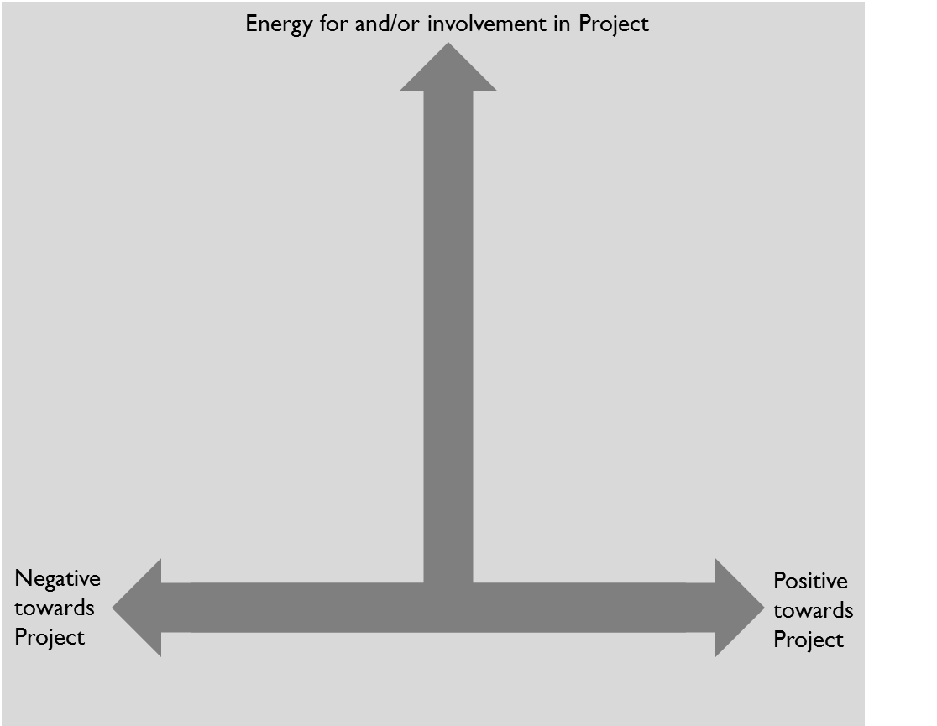
Long-term cynics
Sponsor
Project Sponsor
Project Owner
Business Owner

