Factsheet

The Process of Transition

Change Curve: Fisher’s Transition Curve
John Fisher's model of personal change – The Personal Transition Curve – is an analysis of how individuals deal with change. This model is a reference for individuals dealing with personal change and for managers and organisations helping staff to deal with personal change.

Figure 1: John Fisher’s ‘Personal Transition Curve’, 2012.’

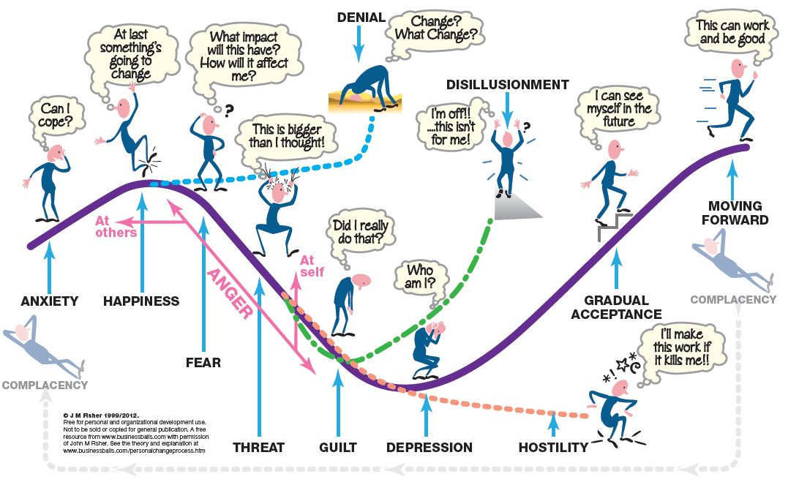

Quote: Explanation of The Personal Transition Curve in John Fisher’s own words.

The Process of Transition

Anxiety.
The awareness that events lie outside one's range of understanding or control. I believe the problem here is that individuals are unable to adequately picture the future. They do not have enough information to allow them to anticipate behaving in a different way within the new organisation. They are unsure how to adequately construe acting in the new work and social situations. There is also the possibility for what McCoy (1977) defined as 'bewilderment' here; which she defined as an awareness of an imminent, comprehensive change in our non-core structure. How we then deal with this dictates how we progress through the rest of the curve and the extent of the impact on our core sense of self.

Happiness.
The awareness that one’s viewpoint is recognised and shared by others. The impact of this is twofold. At the basic level there is a feeling of relief that something is going to change and not continue as before. Whether the past is perceived positively or negatively, there is still a feeling of anticipation and possibly excitement at the possibility of improvement. On another level, there is the satisfaction of knowing that some of your thoughts about the old system were correct (generally no matter how well we like the status quo there is something that is unsatisfactory about it) and that something is going to be done about. In the phase we generally expect the best and anticipate a bright future, placing our own construct system onto the change and seeing ourselves succeeding. One of the dangers in this phase is that of the inappropriate psychological contract. We may perceive more to the change, or believe we will get more from the change than is actually the case. The organisation needs to manage this phase and ensure unrealistic expectations are managed and redefined in the organisations terms without alienating the individual.
The happiness phase is one of the more interesting phases and may be (almost) passed through without knowing. In this phase it is the 'Thank Goodness, something is happening at last!' feeling coupled with the knowledge that we may be able to have an impact, or take control, of our destiny and that if we are lucky/involved/contribute things can only get better. If we can start interventions at this stage we can minimise the impact of the rest of the curve and virtually flatten the curve. By involving, informing, getting 'buy in' at this time we can help people move through the process.

Fear.
The awareness of an imminent incidental change in one's core behavioural system. People will need to act in a different manner and this will have an impact on both their self-perception and on how others externally see them. However, in the main, they see little change in their normal interactions and believe they will be operating in much the same way, merely choosing a more appropriate, but new, action. According to Frances (1999), Fear and Threat are the two key emotions that will cause us to resist change.

Threat.
The awareness of an imminent comprehensive change in one's core behavioural structures. Here people perceive a major change on what they believe to be their core identity or sense of self. The realisation that change that will have a fundamental impact on who we are, how we see ourselves and what is key in our personality to us as individuals. This is the shock of suddenly discovering you're not who you thought you were! It is a radical alteration to our future choices and other people's perception of them as individuals. Their old choices are no longer ones that will work. In many ways this is 'road to Damascus' type of life-changing experience, one that has the potential to 'shake you to the core!' In this phase, people are unsure as to how they will be able to act/react in what is, potentially, a totally new and alien environment - one where the 'old rules' no longer apply and there are no 'new' ones established as yet.

Guilt.
Is an awareness of a dislodgement of our self from our core self-perception. We are not who we thought we were! Once the individual begins exploring their self-perception, how they acted/reacted in the past and looking at alternative interpretations they begin to re-define their sense of self. This, generally, involves identifying what are their core beliefs and how closely they have been to meeting them. Recognition of the inappropriateness of their previous actions and the implications for them as people can cause guilt as they realise the impact of their behaviour. Another of the emotions that may have an impact here is that of 'Shame', in Kellyian terms this is the awareness of a negative change in someone else's opinion of you from what you think it should be. The recognition of this shift in our own and other peoples’ opinion then leads into the next stage.

Depression.
The awareness that our past actions, behaviours and beliefs are incompatible with our core construct of our identity. The belief that our past actions mean we're not a very nice person after all! This phase is characterised by a general lack of motivation and confusion. Individuals are uncertain as to what the future holds and how they can fit into the future 'world'. Their representations are inappropriate and the resultant undermining of their core sense of self leaves them adrift with no sense of identity and no clear vision of how to operate.

Gradual acceptance.
Here we begin to make sense of our environment and of our place within the change. In effect we are beginning to get some validation of our thoughts and actions and can see that where we are going is right. We are at the start of managing our control over the change, make sense of the 'what' and 'why' and seeing some successes in how we interact - there is 'a light at the end of the tunnel!' This links in with an increasing level of Self-confidence, which in Kellyian terms is defined as an awareness of the goodness of fit of the self in one's core role structure – ie: we feel good that we are doing the right things in the right way.

Moving forward.
In this stage we are starting to exert more control, make more things happen in a positive sense and are getting our sense of self back. We know who we are again and are starting to feel comfortable that we are acting in line with our convictions, beliefs, etc. and making the right choices. In this phase we are, again, experimenting within our environment more actively and effectively.

Disillusionment.
The awareness that your values, beliefs and goals are incompatible with those of the organisation. The pitfalls associated with this phase are that the employee becomes unmotivated, unfocused and increasingly dissatisfied and gradually withdraws their labour, either mentally (by just 'going through the motions', doing the bare minimum, actively undermining the change by criticising/complaining) or physically by resigning. From personal experience I can say I've left a company where I found myself becoming increasingly disillusioned with them. My values and theirs were no longer matched and I felt the gulf too big to accommodate whilst still staying true to my construct system.

Hostility.
The continued effort to validate social predictions that have already proved to be a failure. The problem here is that individual's continue to operate processes that have repeatedly failed to achieve a successful outcome and are no longer part of the new process or are surplus to the new way of working. The new processes are ignored at best and actively undermined at worst.

Denial.
This stage is defined by a lack of acceptance of any change and denies that there will be any impact on the individual. People keep acting as if the change has not happened, using old practices and processes and ignoring evidence or information contrary to their belief systems. In many ways when we are faced with a problem, or situation, we don't want, or one that we believe is too challenging to our sense of self we 'constrict' or narrow our range of construction. In this way we eliminate the problem from our awareness. The 'head in the sand' syndrome - if I can't see it, or acknowledge it then it doesn't exist!

Anger.
I have come to recognise over time that there seems to be some anger associated with moving through the transition curve, especially in the earlier stages as we start to recognise the wider implications of change. This is not always present as it seems to be depending on the amount of control people feel they have over the overall process and the focus of the anger changes over time. In the first instance, for those where change is 'forced' on them, the anger appears to be directed outward at other people. They are 'blamed' for the situation and for causing stress to the individual etc. However, as time progresses and the implications grow greater for the individual the anger moves inwards and there is a danger that this drives us into the 'Guilt' and 'Depression' stages. We become angry at ourselves for not knowing better and/or allowing the situation to escalate outside our control.

Complacency.
It has also been suggested that there is also actually a final (initial stage?) of Complacency (King 2007). Here people have survived the change, rationalised the events, incorporated them into their new construct system and got used to the new reality. This is where we feel that we have, once again, moved into our 'comfort zone' and that we will not encounter any event that is either outside our construct system (or world view) or that we can't incorporate into it with ease. We know the right decisions and can predict future events with a high degree of certainty. They are subsequently laid back, not really interested in what's going on around them and coasting through the job almost oblivious to what is actually happening around them. They are, again, operating well within their comfort zone and in some respects can't see what all the fuss has been about. Even though the process may have been quite traumatic for them at the time!
In text references:
McCoy, M M (1977). A reconstruction of emotion. In D Bannister (ed.) New Perspectives in Personal Construct Theory. London: Academic Press.
Frances, M. (1999). Organizational change and personal mythology. Personnel Review.
King, R (2007). Personnel communication.

