Factsheet

Measuring and Communicating the Benefits of Change
Realising the benefits of a change program requires active and focused management throughout the process. You must identify, measure, track and report on benefits and issues if you are going to succeed.
Measurement identifies when things are going well or poorly and allows managers to adjust if there are early warning signs that the change will not deliver as expected. It also provides guidance for organisations so they can prioritise change activities and avoid investing too much or too little.
While measurement needs to be rigorous, it should not be overly complex. The simpler the process, the more transparent it is to all stakeholders. Refer to the template for monitoring and measuring success.

How to do it

1. Establish measures
Use your case for change and business case to establish the measures of success – indicators which show the project outcomes will be achieved. Program logic analysis (below) is a widely used project evaluation technique to help think through which measures are important. This is a structured way to identify and analyse the linkages between inputs, resources, activities and various levels of outcomes.
Figure 1: Linkages between inputs, resources, activities and various levels of outcomes
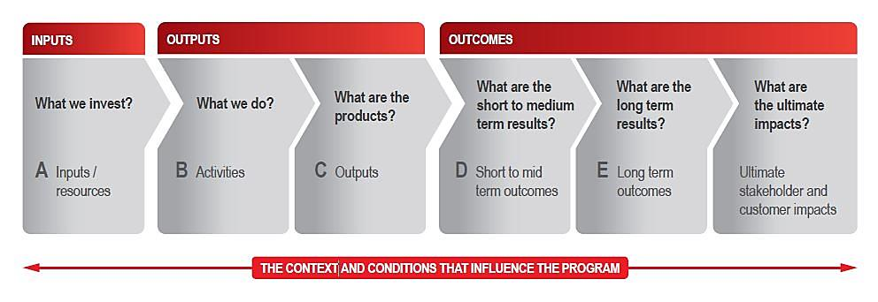
To set benefit measures, move from right to left, ie beginning with the ultimate impacts and moving along to inputs/ resources, and ask yourself these questions:
- How will you know the outcomes have been achieved?
- How will you know the results are achieved?
- How will you know you are getting there?
- What outputs need to be delivered?
- What activities and inputs do we need to monitor to get there?
Resulting measures will include:
- Output measures: a range of project delivery performance measures (milestones) at the project level, including those relating to standards, timing issues, location (where relevant), benefit realisation and costing.
- Outcome measures: a set of agreed key performance indicators that includes lead indicators (short-medium term outcomes) and lag indicators (final outcomes).

Also consider control measures which are often identified as you develop your risk register. Examples include:
- Community satisfaction is negatively impacted by the change.
- A dip in employee engagement.
- Poor quality of service.
- Safety is compromised.
Once you have created your initial list of measures, check that they are:
- Clearly linked to the outcomes or risks (refer diagram – A leads to B leads to C etc).
- SMART: specific, measurable, actionable, realistic, time bound.
- A clear break from the current state.
- Few in number (focus on the most important measures).

2. Plan measurement activities
Measurement requires planning. You will need to understand up front how you will collect and report against each measure, including developing your methodology and reporting templates; what you will measure and how will you build measurement into the project plan.

3. Monitor and measure success, then report on the benefits
As you measure results make sure you respond accordingly. Remain alert to the possibility of gaining new or greater benefits and take action if measures are unlikely to reach their target. The change manager in particular should continuously look for quick wins to maintain momentum and morale. Reinforcing benefits through communications and change management activities also helps maintain momentum. Report benefits to your project sponsor and anyone else identified in your project governance framework.
Adjust for scale
Scale. | Type of Change. | Guidance on how to apply this process.
Small. | Improving and refining methods, policies and procedures; the future state is not very different to the current ways of working. | The task is less onerous for smaller changes and may simply involve tracking a ‘before’ and ‘after’ measure.
Medium. | Distinct modifications to strategies, structures and management processes. | The task is less onerous for medium changes and may only include a few metrics.
Large. | Substantial realignment, restructuring and transformation of all or part of the organisation | A detailed and rigorous benefits realisation approach is required for large, complex change programs. Consider allocating the role to someone with deep analytics skills and a good understanding of the change program.
Success measures
Benefits realisation activities will be successful if:
- there is transparency of performance and leaders understand what the project is delivering
- timely decisions are made when measurement identifies areas for adjustment
- there is an increased focus on benefits delivery
- costs are controlled
- risks are well managed through disciplined process and performance controls; and
- successes are celebrated by internal and external stakeholders.
You are also more likely to succeed if people who can influence the results are held to account for their delivery. This in turn delivers greater:
- return on project investment – returns are delivered faster and more completely
- efficiency in project delivery – clarity on accountability leads to less passing the buck and more problem-solving.

