Corporal Richard Holmyard

26th Australian Infantry Battalion K. I. A. 8 August 1918

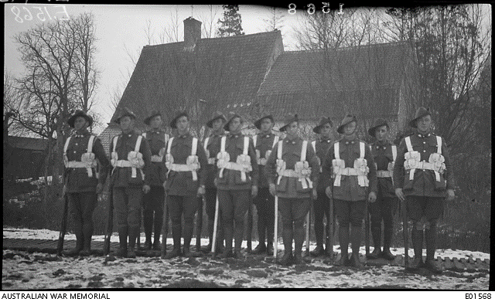z



**AUTHOR’S NOTE**

This research was undertaken as a part of the Frank MacDonald Memorial Prize, an essay based competition open to Year Nine (15 year old) Tasmanian students. In memory of the last surviving Tasmanian World War One veteran Frank MacDonald, the prize helps to promote and preserve the Anzac Spirit and story of the First World War in the Tasmanian community. Six prize winners are selected to take part in a study tour to France and Belgium to visit landmarks and battle fields on the Western Front and also undertake research projects into individual soldiers as a part of the preparation.

For my project I decided to research my great-great uncle Richard George Holmyard. Before undertaking my research I knew that I had three uncles that participated in war, but I had no idea of their tragic stories, involvement in the war and impact that it had on my family, especially my great-grandmother and her children, including my grandfather. It truly has been an amazing experience.

I would like to thank all that made this trip possible, including my parents and teachers who encouraged and helped me to write my essay as well as the Tasmanian Department of Education for paying for the trip. I would epically like to thank all those immediately involved including Judy Travers and Lynne Blake who organised much of the trip and education aspects and lastly to the tour leader Joan Wylie, whom without this would not have been possible.

The essay question was: “Why should we commemorate the centenary of our participation in this conflict?” Before I started researching I didn’t truly understand why. But the First World War is not just about the horrific casualties and stories. 100 years on, it is a foundation stone of national identity. The devastation caused by the Great War and its impact on Australian society changed our nation, how we Australians viewed war and our place in the world. The ANZACS of World War One began a tradition of courage and sacrifice that was continued through other wars such as World War Two, Vietnam and recent conflicts such as Afghanistan. As Doug Baird, the heartbroken father of Corporal Cameron Baird, an Australian soldier killed in Afghanistan in 2013 stated when being presented with his sons Victoria Cross “As a family we would like to think that future generations will… remember those of all families from every war that have fallen, the significance and sacrifice they have done for this wonderful country”. Although the Grief of the Baird family gives an insight into what Australia must have been like after the Great War, their pride also reinforced the importance of commemorating the sacrifice of the many men and women who have served our country, a tradition that began with World War One.

* **Olivia Eade, Student**

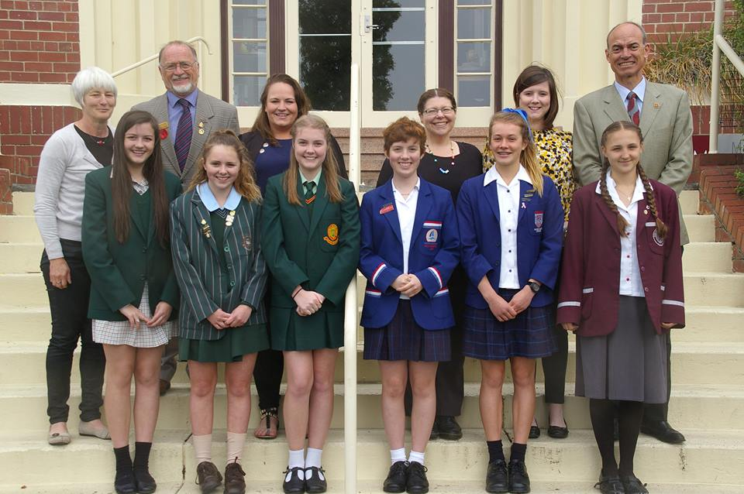

Richard George Holmyard was born in Longford Tasmania in 1891. He spent the rest of his life in the Elizabeth Town and Deloraine area with his seven other siblings and parents. His family lived in a cottage on the outskirts of Elizabeth Town which was a farming district, perfect for supporting the family’s love of horses and hunting. Richard attended Rubicon State School in Elizabeth Town, which was a single teacher public school with an average attendance of 28. After school he found work as a labourer like his father and many of his brothers.

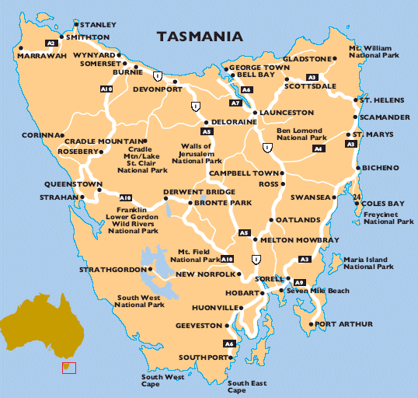

**LONGFORD**

**Elizabeth Town**



His grandparents Hugh and Bridget Holmyard were convicts sent to Tasmania. Hugh Holmyard II was born in 1824 in Somerset England and came from a poor family whom he would often support through poaching; the crime of illegal shooting, trapping or taking of animals from private or public property. In August 1941 at 17 years old he was sentenced to 10 years transportation to Tasmania for the theft of three geese and a gander. His future wife, Bridget O’Neill was born in County Tyrone, Ireland in 1828. Her family migrated to Glasgow, Scotland and in 1842 at just 14 years old she was sentenced to seven years transportation to Tasmania for housebreaking. Hugh and Bridget married in Evandale in Tasmania’s north on the 26 August 1849 whilst still under sentence, with Bridget being released seven months later on the 8March 1850. Hugh was granted a ticked of leave on the 7August 1847 and his sentenced later expired in August 1851. They had a daughter Sarah Jane born in Hobart in 1863, but who died in Launceston a year later in 1864. In 1865 they had their second child Hugh Arnold Holmyard. The family moved to Elizabeth Town in 1878, where they spent the rest of their lives and Hugh II became involved in the local horse racing scene. Bridget died in 1883 whilst Hugh died at 64 in 1906, when Richard was 15.

Their son Hugh Arnold Holmyard married Maria Raynor at just 17 years old in Deloraine on the   
2April 1883 and the pair spent the rest of their lives in Elizabeth Town. Known as ‘the laziest man alive’ he like his parents, was a heavy drinker and shared his father’s love of horses. Maria Elizabeth Ann Rayner was born in Deloraine on the 3 August 1853 and was the oldest of six children. She was 30 when she married the 17 year old Hugh and their marriage lasted 58 years until her death in 1941. Together they had eight children, with the first being Ansel George in 1884. Known as Jack he married Alice Ella Nowell and had eight children, two of which died young. He owned a guest house which his wife Alice ran whilst he worked as a labourer. After Jack, Hugh and Maria had twin boys Edgar Richard John and Elvin Hugh Arnold in 1886. Edgar died at just 17 from complications of a shooting accident, whereas Elvin became a farmer, marrying Ethel May Jones and having three children, two of which served in World War Two. The first Holmyard daughter Sarah Ellen was born in 1887 and had nine children, with five to local thief Hugh Bakes and then another four to Llewellyn Devlin whom she spent the rest of her life with in Burnie in Northern Tasmania. Ivy May who was three years younger than Sarah Ellen had a daughter Doris at just 21, who Maria and Hugh raised as their own. Doris, who was my great-grandmother, married Joseph Eade and had four children, but never kept in contact with the rest of her family. After Doris’s birth Ivy married Hugh Andrew Jago, who also served in World War One but never returned, dying in Belgium in October 1917. He left behind Ivy and her two other daughters. Richard George Holmyard was the sixth Holmyard child born in 1891. He was followed by two more brothers Charles Edward in 1893 and George Edward in 1894. Charles was a Jockey who often got in trouble with the law due to his bad drunken behaviour. George was also a heavy drinker who got into a lot of fights. He married Lucy Jones, the sister of his brother Elvin’s wife Ethel May Jones shortly before he enlisted.

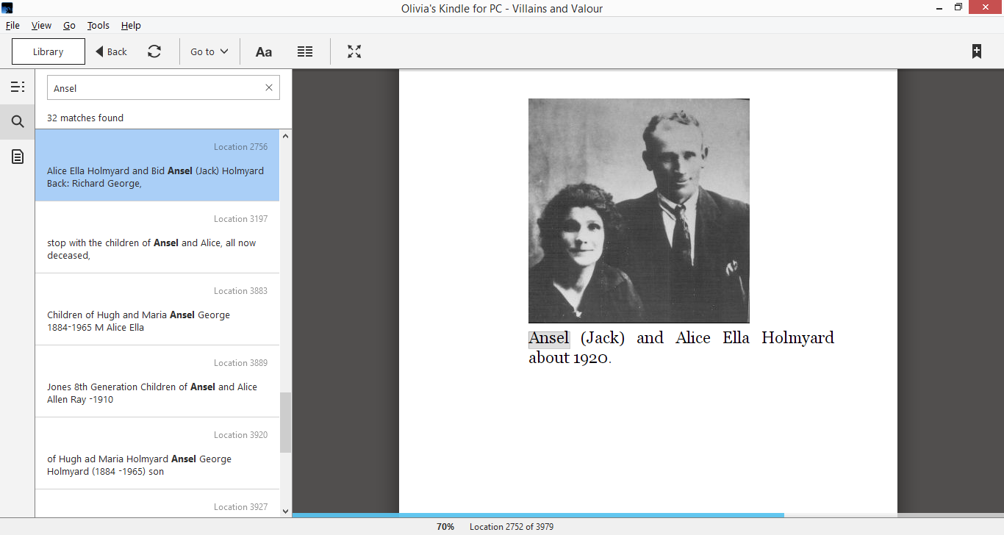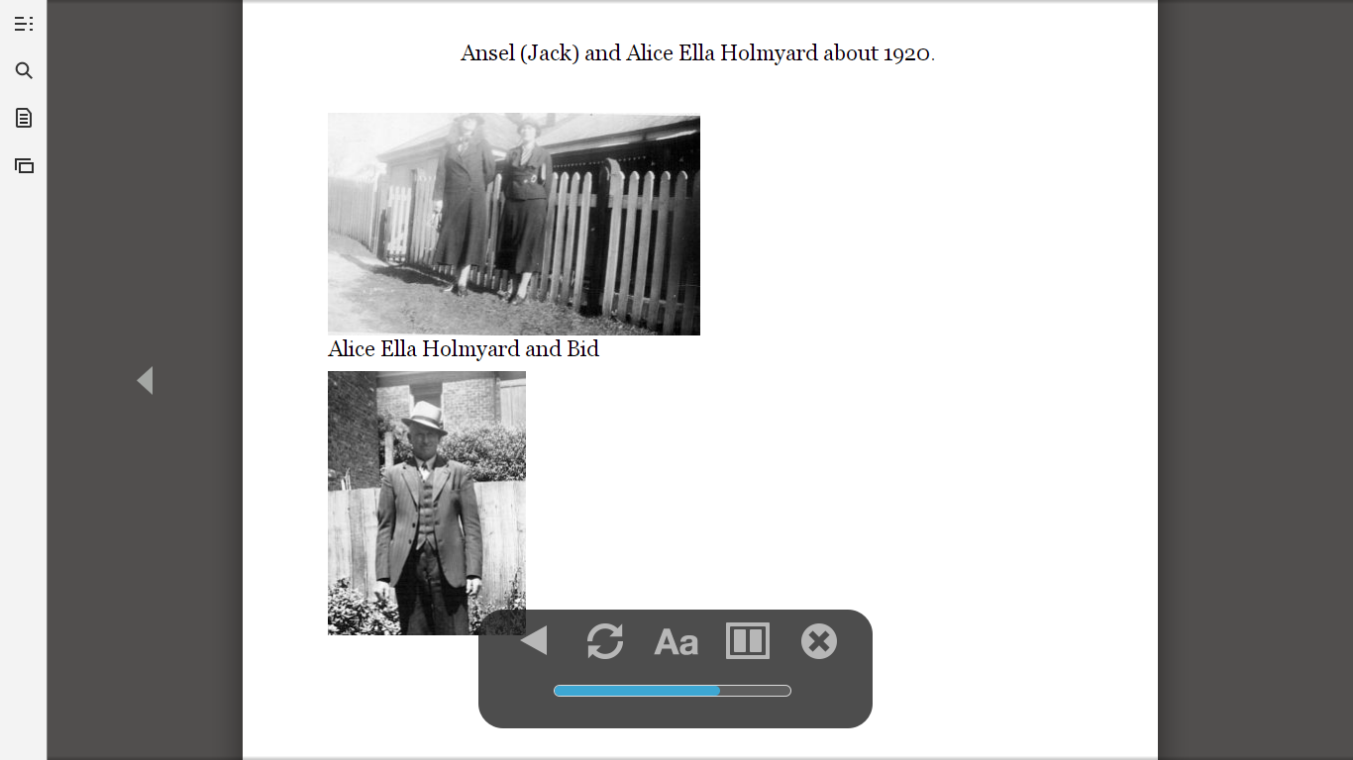

**Left:** A young Alice Nowell and Jack Holmyard, **Right:** Jack in later years

At 23 years old Richard reached about 175.26 centimetres and weighed 63.5 kilograms, which would have been about average for a man. Like his brother George he had a dark complexion and hair with blue eyes as well as a scar on his forehead. He was a Roman Catholic, and unlike his brothers never got in trouble with the law. He also never married, with his mother being recorded as the next of kin on his service records.

**Left:** George Holmyard, Richard’s brother **Right:** Hugh Jago, Richard’s brother in law

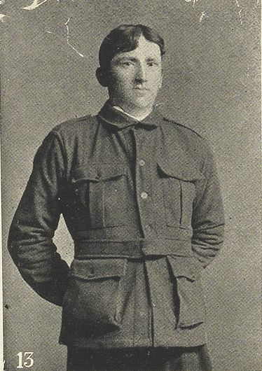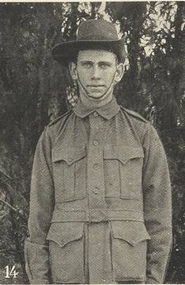

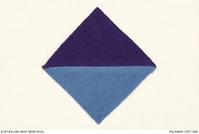Richard enlisted at Claremont in southern Tasmania on the 10 June 1915. At just 23 years old he was placed into the 26th Infantry Battalion and given the rank of Private. On the 17 July, the 26th battalion embarked on the HMAT A67 Orsova from Melbourne and went to train in Egypt. This battalion contained 1,023 men from Tasmania and Queensland, who were concentrated at Enoggera, Queensland. George enlisted five days after at just 21 years old and was placed into the 12th Battalion, along with their first cousin Richard George French. Charles later enlisted on the 3August at 22 years and was placed into the 52nd Battalion.

**Above:** 26th Battalion Colour Patch

A part of the 7th Brigade and 2nd Division, Richard with the 26th Battalion landed at Gallipoli on the   
12 September 1915. Arriving later into the Gallipoli Campaign, the battalion did not take part in any major actions, instead playing a defensive role and becoming responsible for the defence of Courtney’s and Steele’s Posts, towards the northern end of the ANZAC line. They were also responsible for nearby Russel’s Top, where the Australian Trenches were positioned at the famous Battle of the Nek.

Gallipoli itself is a peninsula located on the northwest coast of Turkey. The Gallipoli Campaign was launched by the first lord of the Admiralty Winston Churchill. It was undertaken by British, French and other Commonwealth Forces including Australia to try and put Turkey, one of the central powers (enemy of the allied powers Britain, France, America etc.) out of the war. The campaign only lasted eight months and was a total failure, which forced the allies to have to withdraw troops in December 1915.

Within several weeks of arrival on 2 November Richard contracted diarrhoea and was admitted into hospital. Thousands of soldiers also became infected with the disease due to poor hygiene practices, bad food and infection. Richard’s Brother George who was also fighting in Gallipoli with the 12th Battalion contracted dysentery; an often fatal infection of the intestines caused by poor sanitation. Moved to Egypt for treatment, he later died the 1st Australian General Hospital in Heliopolis, Cairo on the 14November 1915. The youngest of all the Holmyard children he was only 21 years old and left behind his wife Lucy and his unborn son Max Hugh, who was born five weeks later. He was buried at the Cairo War Memorial Cemetery in Egypt, which you can still visit today.

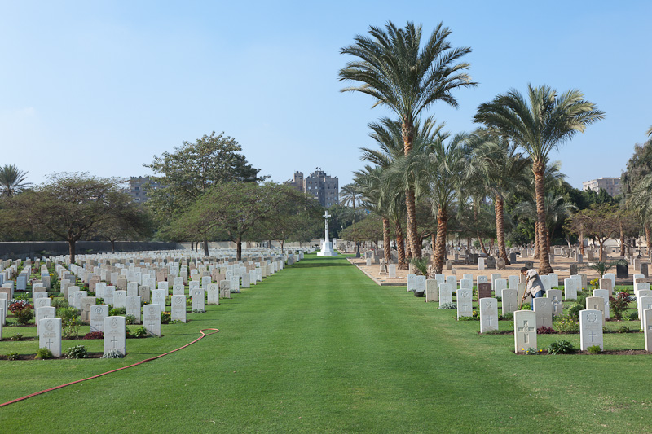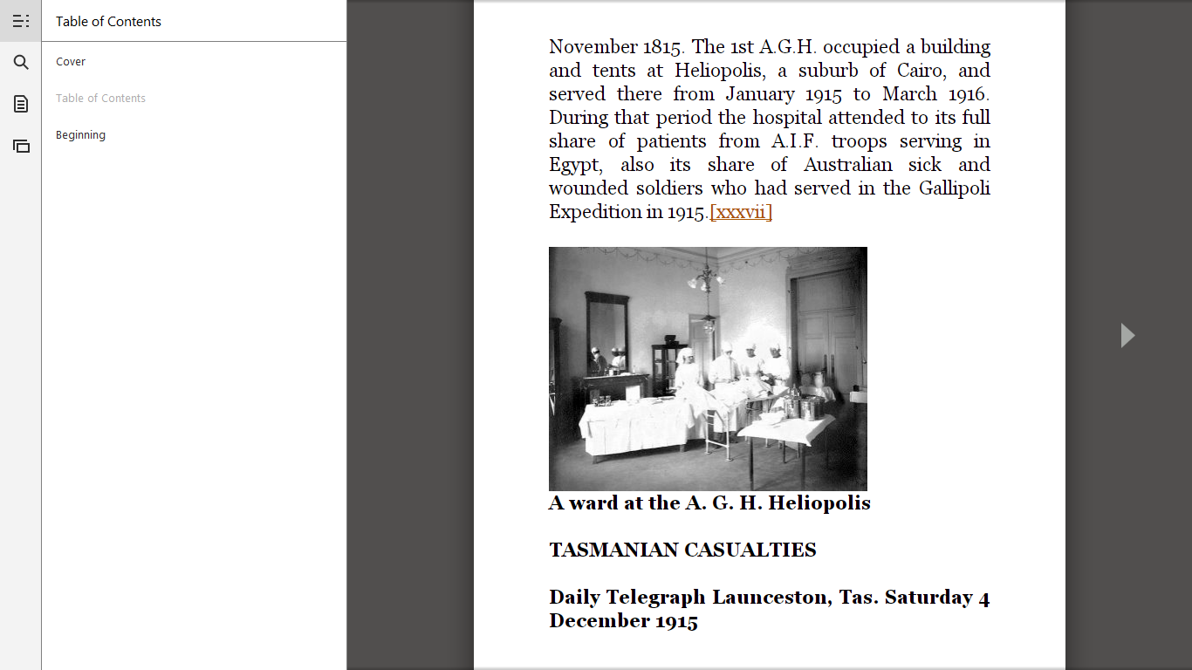

* A ward at the Australian General Hospital in Heliopolis (left) andCairo War Memorial Cemetery (right)

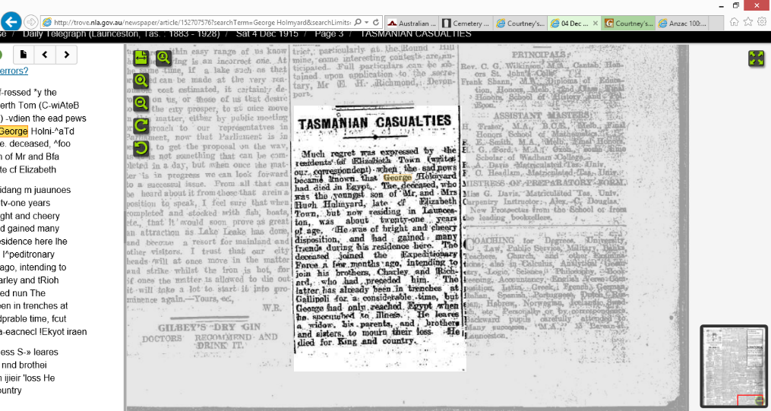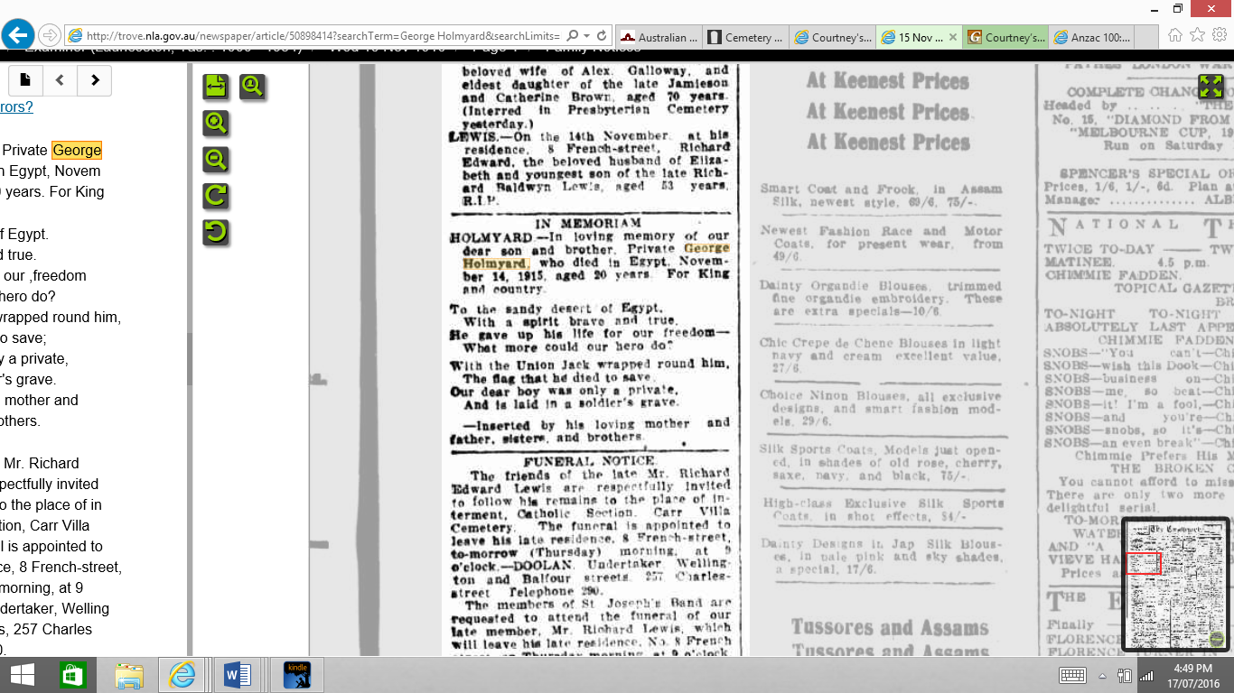

**Above:** notices put in Tasmanian papers after Richard’s brother George’s death

Richard returned to duty on the 15November, with the 26th Battalion withdrawing from the Gallipoli Peninsula on the 12 December. The battalion disembarked at the Greek Island of Mudros and arrived at Alexandria in Egypt on the 9 January 1916. Here the battalion trained, expanded and was reorganised, before arriving in Marseilles on the 23 March 1916. Richard and the rest of his battalion then moved to trenches on the Western front, where they along with the 28th Battalion mounted the first trench raid undertaken by Australians in France on the 6 June at Bois Grenier.

Richard became infected with Otorrhoea, an inflammatory ear disease on the 4July in Belgium and was first treated in the 73 field Ambulance, but was later moved to an Australian Rest Station in France. On the 6th he was diagnosed with Pyrexia or fever and admitted to hospital. He was discharged to duty three days later and returned to his unit in Belgium on the 11July.

Between the 28July and 7August, the 26th Battalion fought its first major battle around Pozieres. The area was originally captured by the 1st Division, resulting in 5,285 casualties. However, after only four days of fighting the 2nd division, including the 26th Battalion was called in to relieve the first. The AIF then mounted two further attacks, with the first being a failure and the second resulting in the seizure of a few German positions. However, like the 1st Division the 2nd suffered heavily, with 6,848 casualties and was relived on the 6 August.

Richard was reported as missing on the 5August during which he was most likely fighting at Pozieres, but fortunately was found to be with his unit four days later. He continued fighting through August, September and on the 4th of October was temporarily promoted to Corporal.

Due to the casualties suffered at Pozieres the 26th Battalion and entire 2nd division was moved to a quieter area of Belgium. In October the battalion moved south to the Somme Valley and participated in two attacks east of Flers, both of which were unsuccessful.

On the 14November Richard was wounded in action with shots to his thighs and right wrist. He was transported to a Casualty Clearing Station and eventually to an ambulance train which took him to a hospital in Rouen in Northern France. After spending three days in Rouen he was sent to England to receive further treatment. He was sent to various hospitals, such as the 3rd Australian General Hospital in Brighton and the 3rd Australian Auxiliary Hospital in Dartford. About a month after he had been shot he was marched in and transferred to the 69th Battalion on the 18th of December. He was eventually taken on strength and placed back into the 26th Battalion. For August he remained training in England, moving between various Military camps such as Hurdcott and Perham Downs. He was again moved to another military camp in Fovant (Area of England) and into the 2nd reinforcements of the 26th Battalion. Then on the 7September he proceeded from Perham Downs back to France arriving in Havre (a French port) a day later. Once in France he was moved back to Belgium and placed back into the 26th Battalion.

A notice was placed in a Tasmanian paper by Richard’s parents after he was wounded. It reads: *Mr and Mrs H. Holmyard of Elizabeth Town, received word from the Defence Department that their son Private Richard Holmyard has been severley wounded while fighting in France. This young soldier was on Gallipoli for many months, and amongst the last to leave. Much sympathy is felt for the relatives , as it is twelve months since the death of their youngest boy in Egypt. The other boy, Charlie, was fighting in Belgium when last heard from. (below left)*

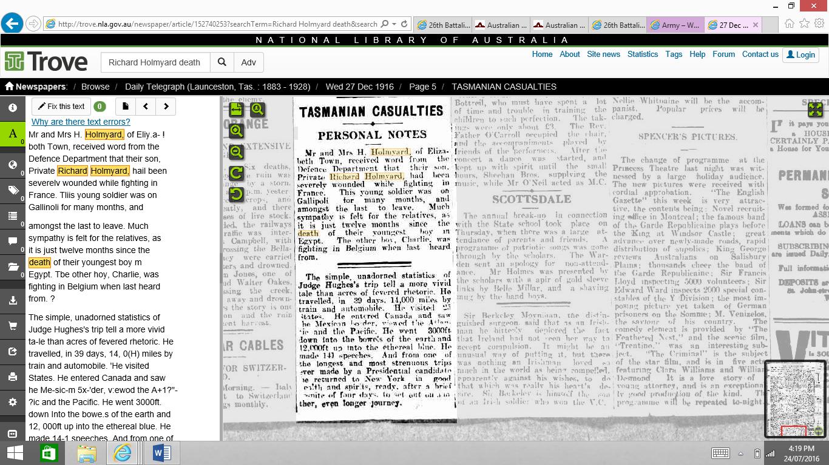

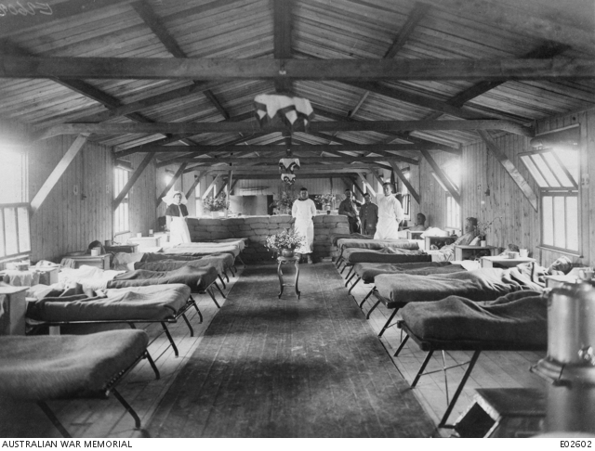

**Above Right:** A ward at the 3rd Australian Auxiliary Hospital in Dartford

Meanwhile the Germans had withdrawn to the Hindenburg Line, causing the 26th Battalion to attack at Warlencourt and Lagincourt in March. Here Captain Percy Cherry was posthumously awarded the battalion’s first Victoria Cross, the highest honour in the Australian Military. The battalion continued to breach the Hindenburg Line, attacking around Bullecourt in a supporting role.

In September the AIF’s operations switched to Belgium and Richard fresh from England participated with his battalion in the Battle of Menin Road.This battle was a part of Third Battle of Ypres (also known as the Passchendaele Campaign) and was an attack undertaken by British and Australian soldiers (1st and 2nd Division) to capture sections of a curving ridge east of Ypres, which Menin Road Crossed. Although the attack was successful the AIF sustained 5,013 casualties and had to overcome fierce German counter-attacks and fight against strong pill-box points.

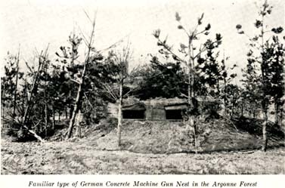

**Above:** German pillbox

The next major conflict the battalion fought in was during the capture of Broodseinde Ridge, which was also a part of the Third Battle of Ypres. The aim was to capture the higher ground that overlooked the town. Before fighting even started the Australians were heavily shelled and during the battle they had to fight against an oncoming German attack and against German pillboxes. Although the Australians gained all their objectives along the ridge they also suffered 6,500 casualties. In this battle Richard was again wounded in action, but re-joined his battalion eight days later.

In February 1918 Russia withdrew from the war due to the Communist Revolution. Fighting then ceased on the Eastern Front and the Germans launched a major offensive, known as the Spring Offensive. This caused the 26th Battalion to attack at Warlencourt near the Somme in March, after it was recaptured by the Germans.

However, Richard also fell sick with Influenza or the flu in March and was admitted to a New Zealand Stationary Hospital in Wisques France. After arriving on the 7th of March he was released 14 days later on the 21st, re-joining it on the same day.

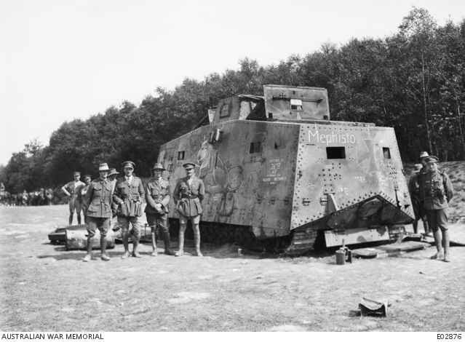

Australian soldiers with ‘Mephisto’ Tank. Photo: Australian War Memorial

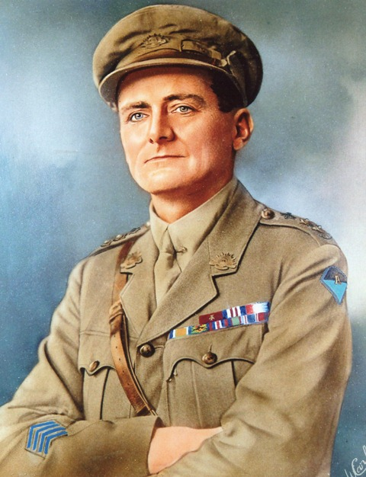

Victoria Cross Recipient Lieutenant Albert Borella

The 26th Battalion continued to fight to turn back the German spring offensive in April. As a part of these operations they captured the first German tank to fall into allied hands, the No. 506 “Mephisto” in July. Three days later the battalion’s Lieutenant Albert Borella was awarded a Victoria Cross for single-handedly capturing a machine-gun and inspiring his men to hold out during heavy enemy counter-attacks. He is the only man ever from the Northern Territory to be awarded with Australia’s Highest Military Honour.

The next major battle they participated in was a great offensive beginning on the 8 August. On this day Richard was killed in action. He was buried at Car Copse British Cemetery in Marcelcave near the Somme in Northern France with 35 other Australian soldiers. However, he was later reburied at Villers Bretonneux Military Cemetery. In Richard’s will he left everything to his mother, with photographs of his grave being sent to his father. Although Richard tried to list his mother as his next of kin the army wrote to her asking if Richard had any nearer relations such as a wife, children or a father who were still alive. As under the Deceased Soldiers’ Estates Act of 1918 they were more entitled to receive these photos than her, despite the fact that she was listed as his next of kin. Maria later wrote back to the battalion with the address of Richard’s father Hugh, who received the medals instead of her.

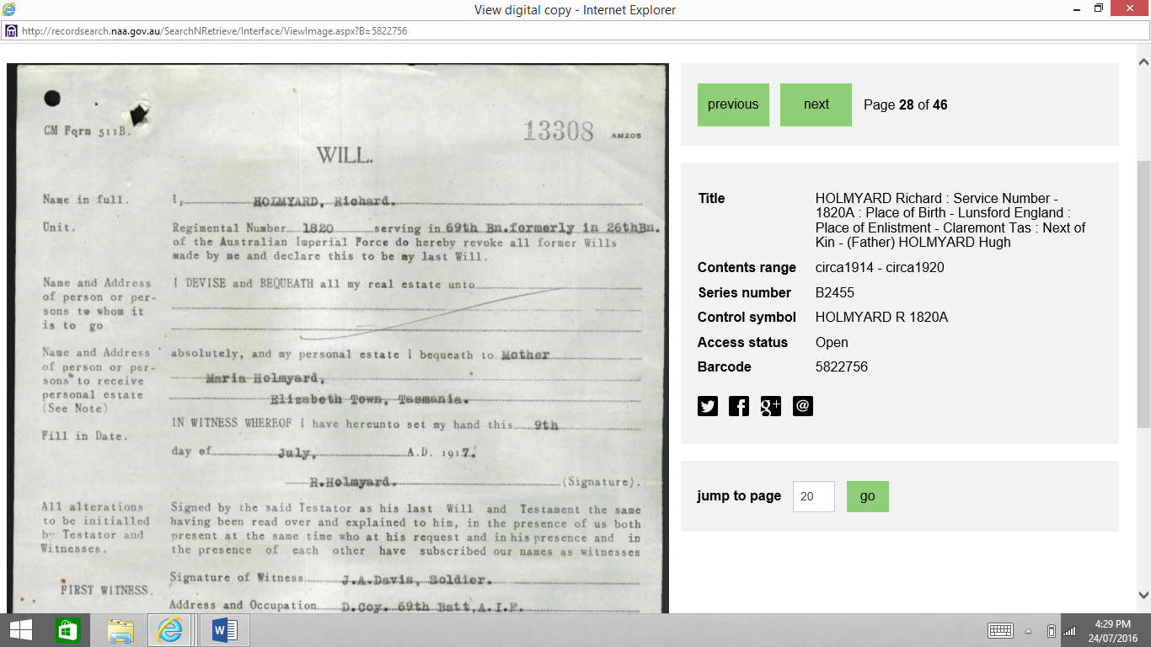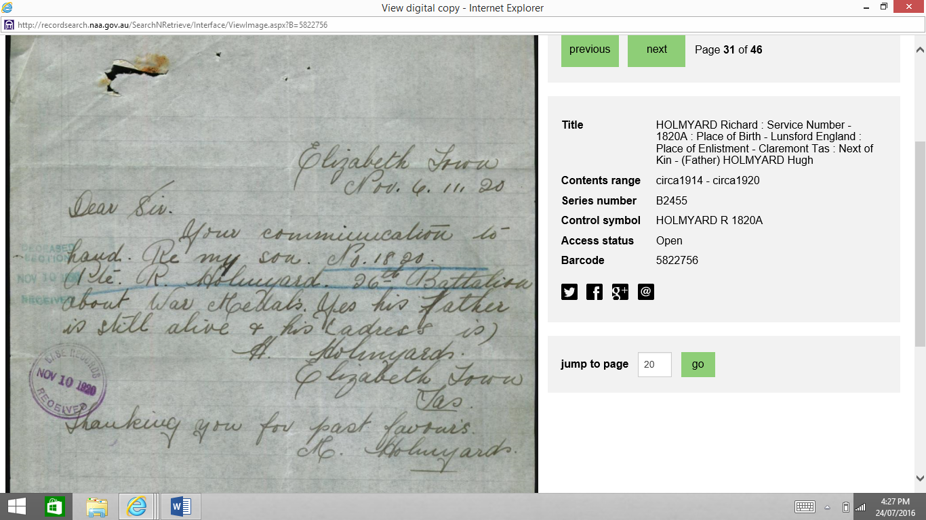

A copy of Richard’s Will and a letter sent by Maria with his father’s details.

Three months later the armistice was signed to end the war on the 11 November 1918. Charlie was the only one of the Holmyard brothers to survive the war and returned to Australia on the 1May 1919. After returning home he moved to New South Wales and settled in the Riverina Area. He married a woman named Mildred Walker becoming step father to her children but never having any of his own. Despite all that he experienced in the First World War he also served in the Second World War, and spent his later years living at the Sportsman’s Arms Hotel in Deniliquin in the Riverina Region (inland New South Wales, close to the Victorian Border). He died on the 11 May 1969.

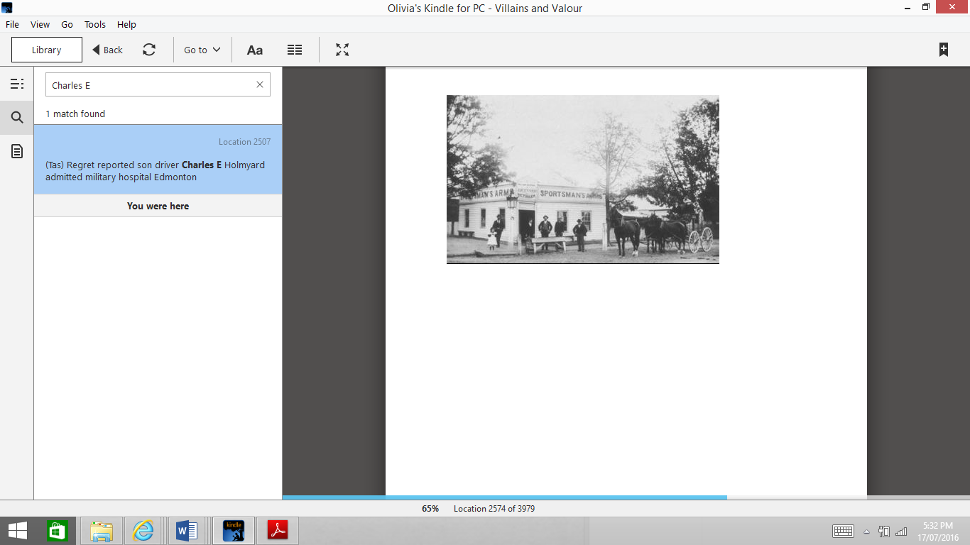

The Sportsman’s Arms Hotel in Deniliquin, Australia

The rest of the Holmyards were absolutely devastated after the loss of two of their sons. During the war they also lost Ivy’s husband Hugh Andrew Jago and their cousin George Richard French in 1916. The family continued to live in the Elizabeth Town and Deloraine Area, with four men from the next generation serving in the Second World War. They would never talk about the First World War and hid the medals and other items that acted as reminders of it.

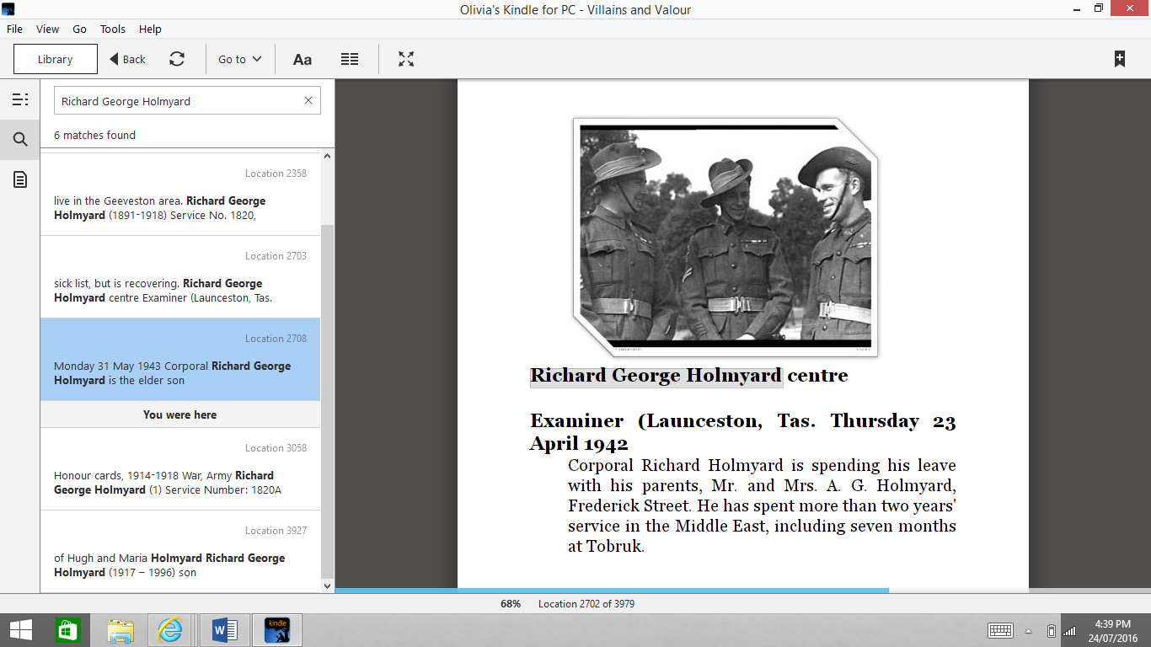

* This photo of Richard George Holmyard (centre) and friends appeared in *The Examiner*, Launceston, 23 April 1942, and reported that Corporal Richard Holmyard was spending his leave with his parents Mr and Mrs G Holmyard, of Frederick Street, and Corporal Holmyard had spent two years serving in the Middle East, with seven months at Tobruk.

During World War Two, Corporal Richard George Holmyard who was the son of Ansel Holmyard and named after both of his uncles won the Distinguish Conduct Medal (second highest honour in Australian Army) for exceptional courage at Rabi, Gamar and Tulagua. Trevor Richard Holmyard, the son of Elvin Holmyard was killed in action in Egypt on the 17July 1942 at just 25 years. Elvin’s other son Murray Kenneth Holmyard and Max Hugh Holmyard, the son of George both served and returned home.



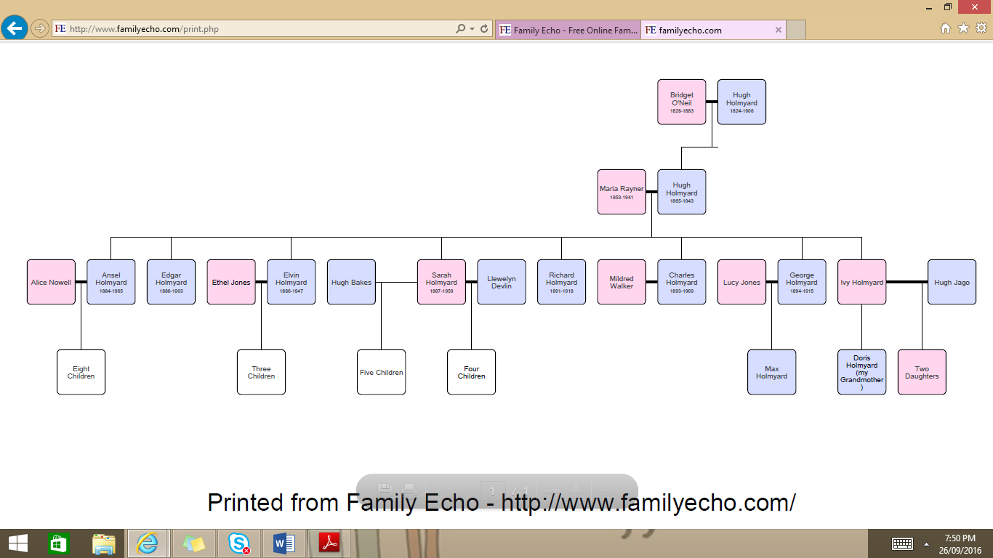

**Holmyard Family Tree**